NetBrain Single Pane of Glass (SPoG) Integration_ServiceNow

NetBrain applicable versions: 7.1a1, 8.0

Contents

Introduction 1

What is NetBrain Single Pane of Glass (SPoG)? 1

How does NetBrain SPoG work? 1

ServiceNow REST API 2

Use REST API Explorer to explore ServiceNow REST API 2

Understand ServiceNow Table Schema 3

Create NetBrain API Parser 4

Define NetBrain API Plugin 5

Test NetBrain API Server Instance Connectivity to ServiceNow Instance 6

Create NetBrain Qapp with NetBrain API Parser 7

General NetBrain Data View by NetBrain Qapp 7

Appendix 7

NetBrain API Plugin Code Standard 7

NetBrain API Parser Code Standard 7

References 7

# Introduction

## What is NetBrain Single Pane of Glass (SPoG)?

NetBrain integrates with different data sources within an enterprise to use NetBrain map and Qapp for data correlation, analysis, and troubleshooting.

## How does NetBrain SPoG work?

NetBrain has Python function defined in API Plugin to send HTTP/HTTPS request to 3rd party system to query 3rd party system data via REST API. End user needs to specify the 3rd party system REST API for certain corresponding data in NetBrain API Parser. NetBrain will then be able to implement the parser in a Qapp to further process the REST API retrieved data to generate NetBrain Data View on NetBrain maps.

This documentation uses display ServiceNow Incident table data as NetBrain Data View (DV) as an example to explain how ServiceNow SPoG is implemented in NetBrain system.

# ServiceNow REST API

## Use REST API Explorer to explore ServiceNow REST API

To define NetBrain API Parser, end user needs to first understand what data needs to be pulled from ServiceNow and the corresponding ServiceNow REST API to query such data.

Search “REST API Explorer” in ServiceNow to navigate to REST API Explorer under System Web Services.

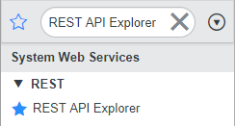

Brief introduction of using ServiceNow REST API Explorer:

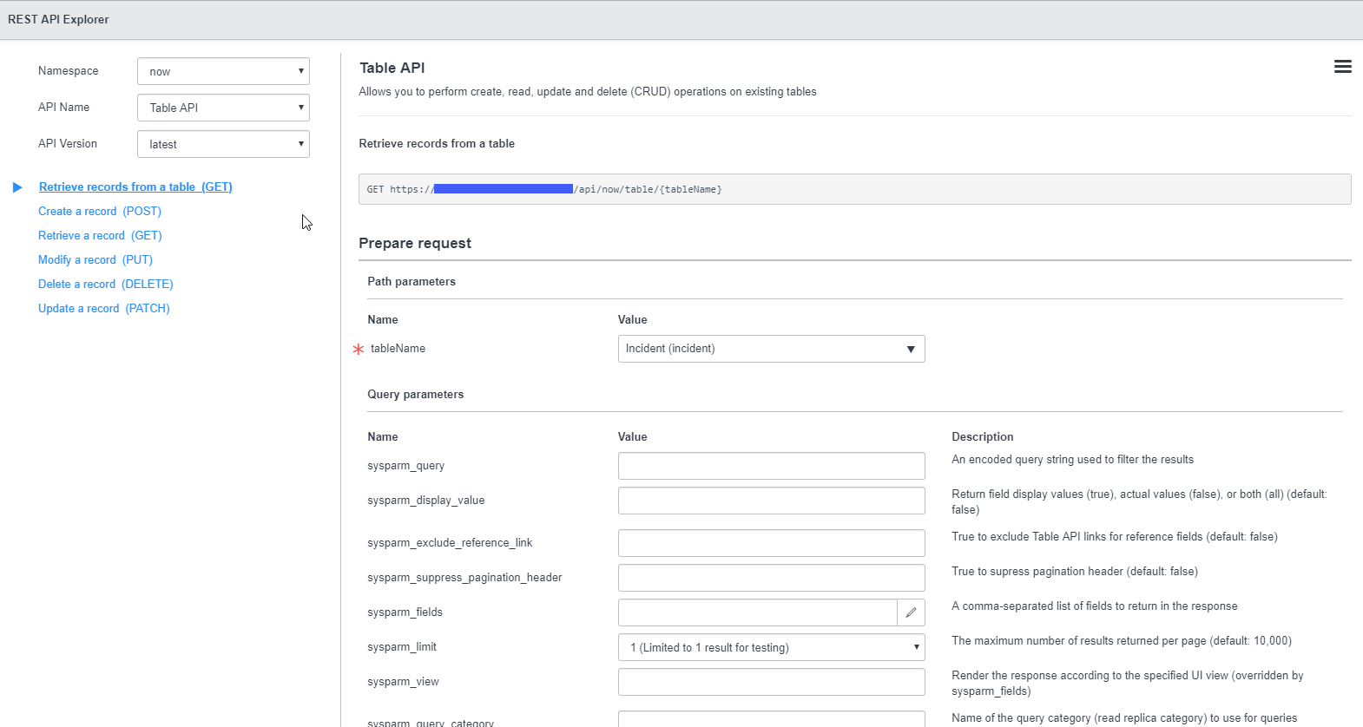

1. API Name: Table API
2. Path parameters
   1. tableName: Search for the table and select it
3. Query parameters:
   1. These parameters are the http query parameters which can filter out the result to a more accurate output instead of pulling all the data from the table. For more detailed explanation for each query parameters, refer to the descriptions of each query parameter.

For more details on REST API Explorer, refer to <https://developer.servicenow.com/app.do#!/document/content/app_store_doc_rest_integrate_kingston_t_GetStartedAccessExplorer?v=kingston>

## Understand ServiceNow Table Schema

Querying the whole table data instead of querying more accurate data with query parameters is more resource consuming on both transmission and calculation perspective. In another hand, it will also require more complex logic to be implemented on NetBrain parsing process. In this case, as a sideway support knowledge of accurately querying ServiceNow table data, understanding ServiceNow Table Schema is very important and helpful to trim the queried result by ServiceNow REST API.

Search “Tables ” in ServiceNow to navigate to Tables & Columns under System Definition.

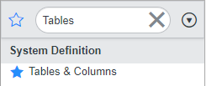

Brief introduction of reviewing ServiceNow Table Schema:

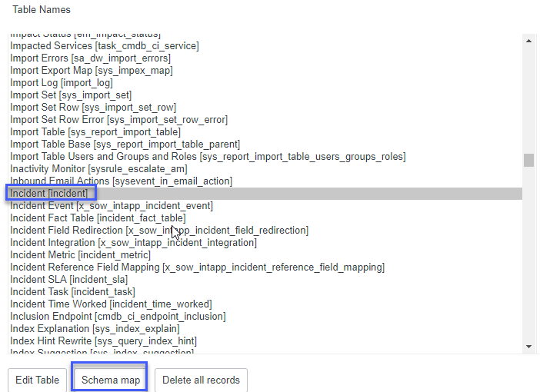

1. Select the table name from Table Names table
2. Click on Schema map button

For more details on Table Schema, refer to <https://docs.servicenow.com/bundle/london-platform-administration/page/administer/table-administration/concept/c_SchemaMapForTables.html>

# Create NetBrain API Parser

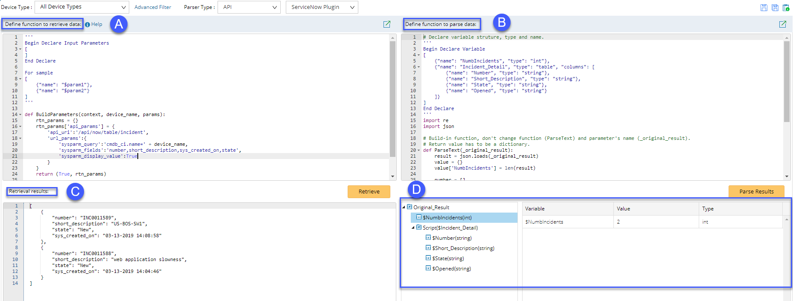

1. Define retrieve data function
   1. Customize Python functions:
      1. BuildParameters()

Define ServiceNow REST API parameters.

* api_url: ServcieNow REST API HTTP URI without host server domain name section
* url_params: ServiceNow REST API HTTP Query parameters
  + 1. RetrieveData()

Call API Plugin Python function to retrieve data via REST API

1. Review retrieved data
2. Define parse data function
3. Review parsed data

# Define NetBrain API Plugin

NetBrain API Plugin has a build-in instance for ServiceNow, which contains HTTP Get function (get_data()).

The HTTP request is using Basic Authentication to be authenticated by ServiceNow for each API call.

The username and password information are inherited from NetBrain API Server Manager instance.

No customization and modification are required in API Plugin.

# Test NetBrain API Server Instance Connectivity to ServiceNow Instance

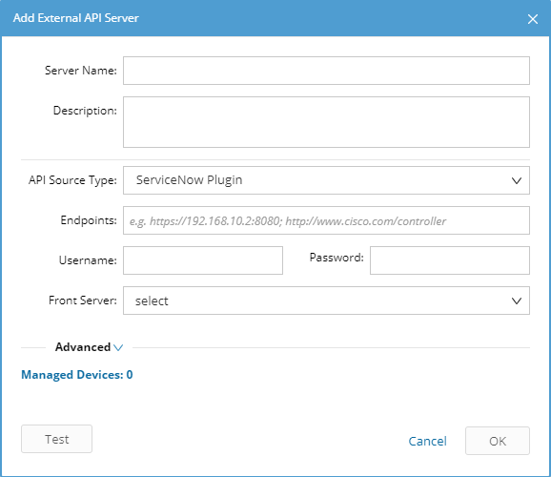

1. Navigate to Domain Management – API Server Manager
2. Click Add button to add an External API Server
3. Fill out all fields in the pop-up dialog above
4. Select “ServiceNow Plugin” for ServiceNow integration
5. Click Test button to test connectivity from NetBrain Front Server to ServiceNow domain

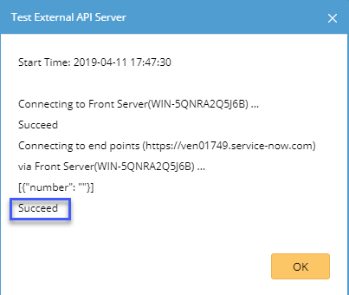

# Create NetBrain Qapp with NetBrain API Parser

# General NetBrain Data View by NetBrain Qapp

# Appendix

## NetBrain API Plugin Code Standard

1. To easily maintain and scale API Parser Library in the future, only extract parameters passed from Parser. DO NOT hard code any REST API HTTP parameters in API Plugin Python functions.
2. To prevent more HTTP request sending from NetBrain to 3rd party systems, use Basic Authentication for HTTP calls as long as 3rd party system supports Basic Auth.
3. To easily organize HTTP call parameters, return the following 4 values to get_data() function:
   1. endpoint: 3rd party system host address, which is defined in API Server Manager
   2. username: 3rd party system login username to be used by HTTP call, which is defined in API Server Manager
   3. password: 3rd party system login password to be used by HTTP call, which is defined in API Server Manager
   4. api_params: HTTP request parameters defined in API Parser
4. To simplify the output in API Server Manager Test result, trim the sample REST API call result as much as possible in _test() function.

## NetBrain API Parser Code Standard

1. Define HTTP request parameters in BuildParameters() function by following the Python dictionary structure below:

rtn_params['api_params'] = {

'api_uri':'/api/now/table/incident',

'url_params':{

'sysparm_query':'cmdb_ci.name=' + device_name,

'sysparm_fields':'number,short_description,sys_created_on,state',

'sysparm_display_value':True

}

}

1. Trim the result by better defining the query parameters, instead of further process the returned result later in NetBrain parser.
2. Implement the main logics by calling API Plugin functions in RetrieveData() function

# References

1. ServiceNow REST API Explorer: <https://developer.servicenow.com/app.do#!/document/content/app_store_doc_rest_integrate_kingston_t_GetStartedAccessExplorer?v=kingston>
2. ServiceNow Schema Map for Tables: <https://docs.servicenow.com/bundle/london-platform-administration/page/administer/table-administration/concept/c_SchemaMapForTables.html>